Quiz-3 (A & B): Solution

Consider the following plot of TCP window size as a function of time for two TCP connections A and B. In this problem, we will suppose that both TCP senders are sending large files. We also assume that the packet loss events are independent in connection A and B.
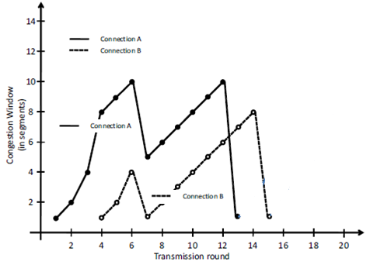

a) Considering the above values of congestion window (cwnd) for these connections, can we identify the type of TCP connections (Reno or Tahoe) that have been used by connection A and B? Justify your answers.

Considering the different changes of cwnd in the 6th and 12th transmission rounds, connection A uses TCP Reno, whereas we cannot say that connection B uses TCP Reno or Tahoe.

b) How the value of Threshold parameter varies between the 1st and the 14th transmission rounds for each connection?

Connection A: The value of Threshold is 8 between the first and the sixth transmission round. It is 5 between the sixth and the fourteenth transmission round.
Connection B: With the above plot we cannot identify the exact value of Threshold for connection B between the first and the sixth transmission round. It could have any value larger than 4. From the sixth to the fourteenth transmission round, it is 2 and at the fourteenth transmission round it is 4.

c) At the 12th transmission round for connection A, is segment loss detected by a triple duplicate ACK or by timeout? Justify your answer.

It is detected by timeout, because cwnd has dropped to 1 at the 13th transmission round.

d) Draw (on the figure above) the cwnd values of both connections up to the 20th transmission round, considering that there is no further timeout or duplicate ACK situation for any of the connections.

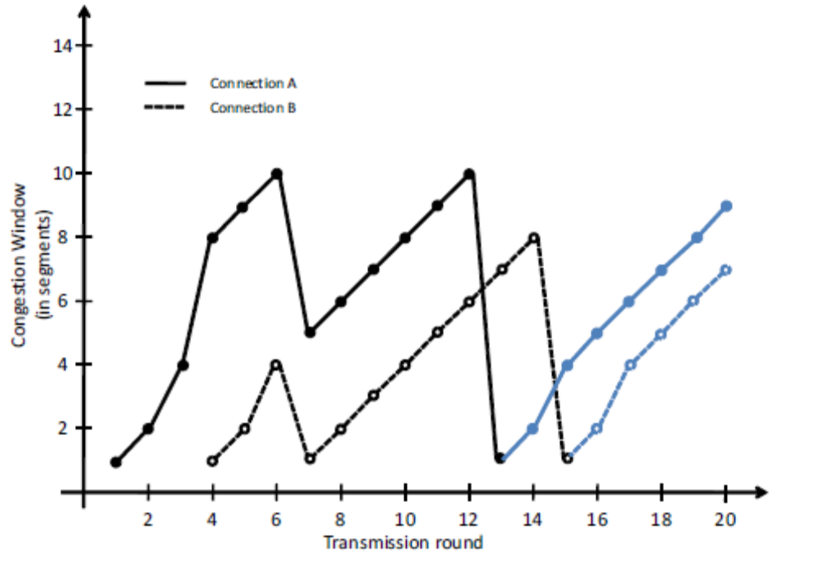

e) Consider your solution in part d; assume that the segment size is 1460 bytes and that a total of 87600 bytes have been successfully transmitted over connection A before the 13th transmission round. At which transmission round the cumulative amount of the successful transmitted data is equal to 163520 bytes? Again we assume that there is neither timeout nor duplicate ACK after the 13th transmission round.

87600 is equal to 87600/1460 = 60 segments. We would like to know at which transmission round the 163520/1460 = 112 segments will be transmitted.
Assume x is the number of segments transmitted in that particular round (the one we are looking for) then, the sum of segments transmitted after round 13 would be:
1 + 2 + 4 + 5 + 6 + 7 + 8 + ……… + x = 112 - 60 = 52
x(x + 1)/2 - 3 = 52
x = 10.
Now round 21 is the transmission round in which 10 segments will be transmitted and cumulative transmitted data will become 163520 bytes.

